

**ENUMERATION AND VULNERABILITY ANALYSIS**

**Faculty of Computer Sciences and Engineering**

**CY-201 Project**

**Section E - Cys**

**Muhammad Afeef Bari 2023356**

**Muhammad Ismail 2023452**

**Muhammad Abubakar 2023352**

#### **1.1 Enumeration (Module 4)**

Enumeration is the process of establishing an active connection with a target system and systematically extracting critical information such as:

* Usernames and groups
* Machine and hostnames
* Operating Systems and services
* Policy settings and SNMP details

It’s an essential step in penetration testing after scanning and footprinting. It often uses protocols such as NetBIOS, SNMP, LDAP, and RPC to gather information. Enumeration techniques typically function in intranet environments and help uncover deeper insights about the internal network structure and potential attack vectors.

#### **1.2 Vulnerability Analysis (Module 5)**

Vulnerability Analysis is the process of identifying, classifying, and prioritizing vulnerabilities in a system, network, or application. It typically follows enumeration and includes:

* Detecting known security flaws
* Identifying misconfigurations
* Recognizing unpatched software
* Scanning with tools such as Nessus, OpenVAS, Nikto, and Nmap scripts

This phase enables ethical hackers to evaluate potential risks and recommend mitigation strategies before an actual attacker exploits the flaws.

### **2. Lab Setup (Oracle VM VirtualBox)**

To simulate enumeration and vulnerability analysis, set up the following virtual machines using Oracle VM VirtualBox:

#### 

#### 

#### 

#### 

#### **2.1 Required Virtual Machines**

| **VM Name** | **Purpose** | **Role** |
| --- | --- | --- |
| Windows 11 | Target system for user enumeration | Client |
| Windows Server 2022 | AD, file sharing, DNS service simulation | Target Server |
| Windows Server 2019 | Legacy system with services | Target Server |
| Parrot Security OS | Attacker machine (tools pre-installed) | Attacker VM |
| Ubuntu | General-purpose Linux target | Client/Server |
| Android Emulator | Vulnerable mobile endpoint | Client/IoT |

#### **2.2 Network Configuration**

* Use Host-Only Adapter for internal network simulation
* Set all VMs on the same virtual network (192.168.x.x) to simulate an intranet
* Ensure Internet connectivity via NAT Adapter for downloading additional tools if needed (only for attacker machine)

#### **2.3 User Accounts & Services Setup**

* Create dummy users and groups on Windows VMs
* Enable services like SMB, FTP, SNMP, RDP, and IIS
* Configure shared folders with default or weak permissions
* Set Admin accounts with test passwords (e.g., Admin123)

**3. Tools and Techniques Used**

#### **Enumeration Tools (Module 4)**

* Net View, nbtstat, ipconfig, netstat (Windows commands)
* Nmap with scripts: nmap -sS -sV -Pn -T4
* SuperEnum and RPCScan
* PowerView and BloodHound for Active Directory Enumeration
* Metasploit auxiliary modules

#### **Vulnerability Analysis Tools (Module 5)**

* Nessus or OpenVAS for full vulnerability scans
* Nikto for web server flaw detection
* Searchsploit to map discovered versions to known exploits

### **4. Lab Objectives**

#### **Enumeration objectives**

Extract:

* + Machine names and OS versions
  + Running services and open ports
  + Network shares
  + Usernames and groups
  + Password policies and audit settings

#### **Vulnerability Analysis Goals**

* Identify:  
  + Unpatched services (e.g., SMBv1, old RDP versions)
  + Weak configurations (e.g., anonymous login)
  + Exposed sensitive files or services
  + Known CVEs affecting software versions

**Module 4:Enumeration**

**Lab 1: Perform NetBIOS Enumeration**

Performing this lab provides valuable hands-on experience in NetBIOS enumeration. NetBIOS enumeration is the process of gathering information from a system through the NetBIOS (Network Basic Input/Output System) service. It allows an attacker or security tester to obtain details such as:

* Computer name
* Username
* Shared resources (files/folders/printers)
* Domain/workgroup name

The nbtstat command is used to diagnose and troubleshoot NetBIOS over TCP/IP issues in a network. It provides information about NetBIOS name resolution, active connections, and name tables of both local and remote systems. This helps network administrators detect problems like name conflicts, connection failures, or unauthorized systems, making nbtstat a valuable tool in network diagnostics and security analysis.

In this lab, learners practice using tools like NBTscan, SNMP enumeration tools, and NetBIOS commands to gather data such as usernames, shared resources, network devices, and system details. The goal is to demonstrate how attackers can map networks and prepare for further exploitation, reinforcing the importance of securing exposed services.

Screenshots below show the demonstration of the lab:

Using window 11 to target a window server 2019 machine

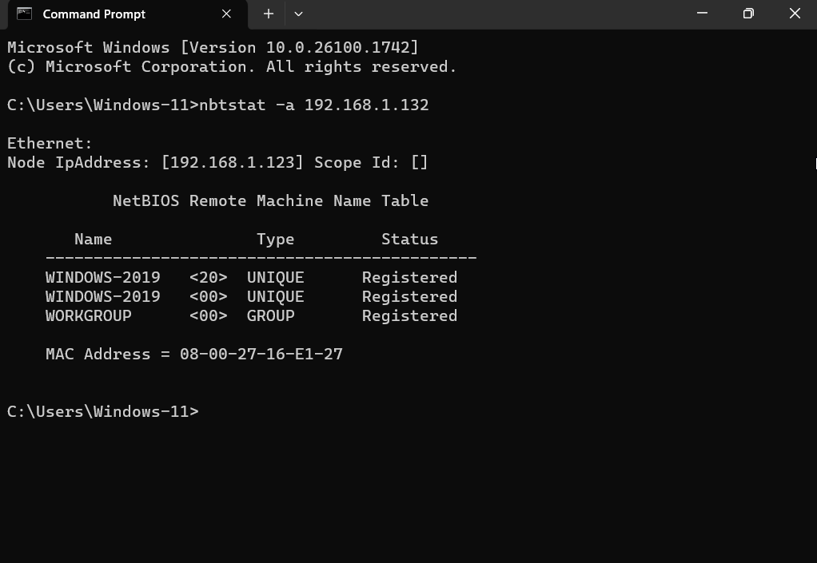

This shows the NetBIOS name table of a remote computer in this case Windows server 2019.

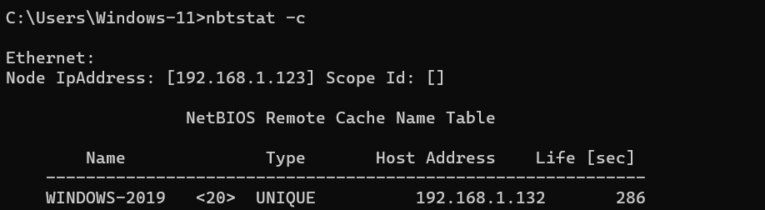  
The above screenshot displays the contents of the NetBIOS name cache, the table of NetBIOS names and their resolved IP addresses.

Now using window 11 machine to target window server 22 machine

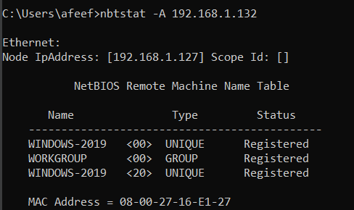

**Task-3: Enumeration using an NSE Script**

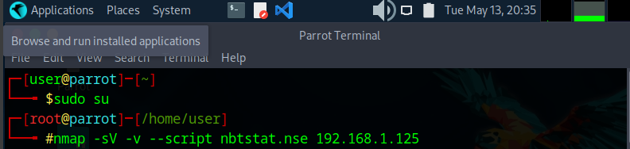

In the above screenshot the -sV detects the services versions, -v gives all the host outputs and the ports in the output, and the –script nbtstat.nse performs the NetBIOS enumeration.

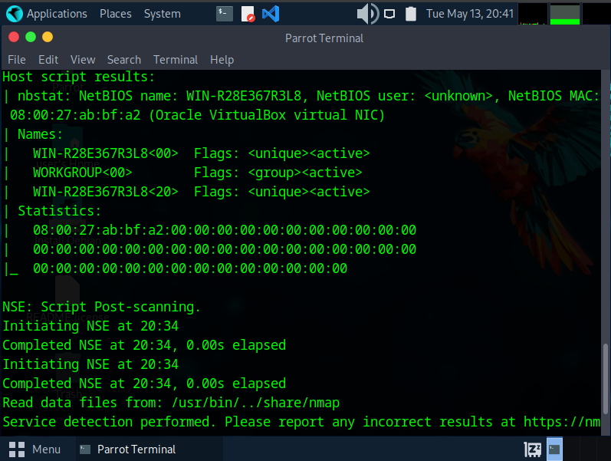

The above shows the results which display all the open ports and services along with their versions. Under the host script results are the details about the target system such as NetBIOS name, NetBIOS user and the NetBIOS MAC address etc.

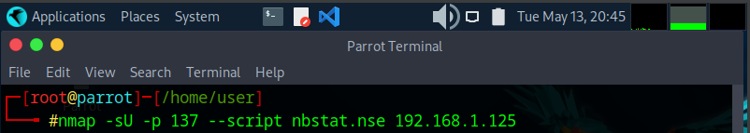

-sU performs a UDP scan, -p specifies the port to be scanned, and –script nbstat.nse performs NetBIOS enumeration.

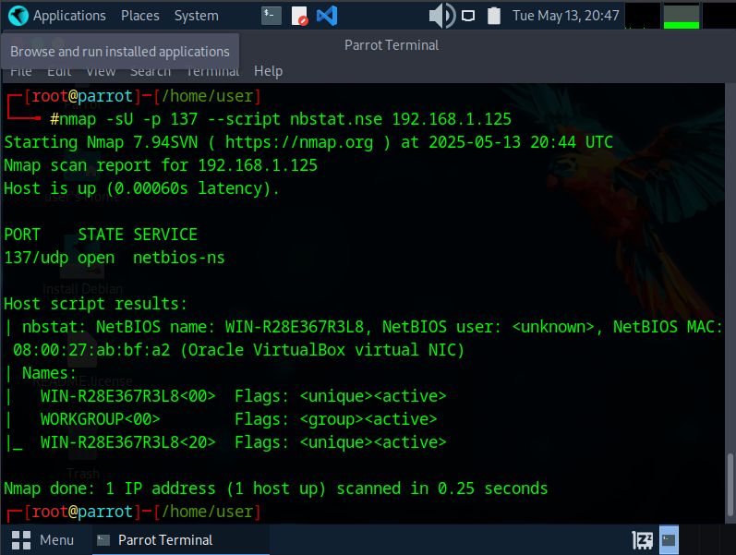

This concludes the demonstration of performing NetBIOS enumerations using an NSE script.

**Lab 2**

**Perform SNMP enumeration**

SNMP enumeration is a critical technique in ethical hacking used to gather information about network devices by exploiting the Simple Network Management Protocol (SNMP). This protocol, commonly used for monitoring and managing network equipment, relies on community strings (similar to passwords) for authentication, with default strings like "public" and "private" often left unchanged, making them prime targets for attackers. In this lab, tools such as Snmpwalk and Snmpcheck are used to query SNMP-enabled devices, extracting details like system configurations, running services, open ports, and routing tables. The process begins by identifying SNMP-enabled devices using network scanners like Nmap, followed by querying Object Identifiers (OIDs) with commands such as snmpwalk -v2c -c public <target_IP> system or snmpcheck -t <target_IP> -c public to retrieve structured data. The gathered information can reveal vulnerabilities like weak credentials or misconfigurations, which attackers could exploit. To mitigate these risks, organizations should replace default community strings, implement SNMPv3 for encryption and authentication, and restrict SNMP access through firewalls. This lab highlights the importance of securing SNMP to prevent unauthorized access and reinforces ethical hackers' understanding of network reconnaissance techniques.

**Task-1: Perform SNMP enumeration using snmp-check**

Checking if port 161 is open and being used by SNMP.

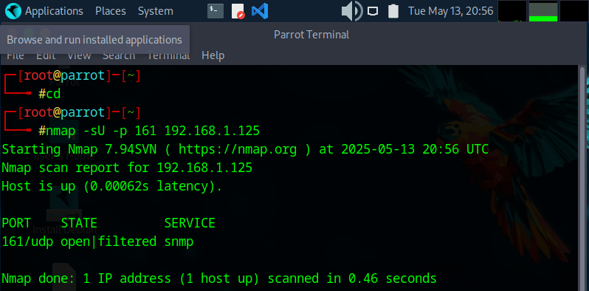

Since we have established that the SNMP service is running on the target machine. Now let us exploit it to obtain the information about the target system.

**Lab 3**

**Perform LDAP Enumeration**

LDAP enumeration is a technique used to extract information from Lightweight Directory Access Protocol (LDAP) services, which are commonly deployed in organizations to store user credentials, group memberships, and other directory-related data. In this lab, tools like ldapsearch, Softerra LDAP Browser, or ADExplorer are used to query LDAP servers, often targeting Active Directory (AD) environments. Attackers can perform anonymous or authenticated LDAP queries to gather sensitive details such as usernames, email addresses, department names, and even password policies. This information can be leveraged for further attacks like brute-forcing credentials or privilege escalation. To defend against LDAP enumeration, organizations should disable anonymous LDAP binds, enforce strong authentication mechanisms, implement access controls, and monitor LDAP logs for suspicious queries. This lab demonstrates how attackers exploit misconfigured LDAP services and underscores the importance of securing directory services to prevent unauthorized data exposure.

**Lab 4**

**Perform NFS Enumeration**

Performing this lab provides valuable hands-on experience in enumerating NFS (Network File System) services using two powerful tools—SuperEnum and RPCScan. NFS is commonly used to allow systems on a network to share files and directories. However, if misconfigured, it can expose sensitive information to unauthorized users. This lab helps you understand how NFS operates and why it’s essential to secure it properly in enterprise environments.

By using SuperEnum, you learn how to perform basic enumeration of open ports, including NFS running on TCP port 2049. The tool helps automate the discovery of accessible services, making it easier to identify potential vulnerabilities. Meanwhile, RPCScan directly interacts with RPC services on the target machine. It reveals detailed information about running services such as portmapper, nfs and mountd, which are all critical components in NFS operation. Understanding these services allows you to spot misconfigurations that could be exploited in a real attack scenario.

The insights gained from this lab highlight the importance of properly securing RPC-based services. You learn how attackers use these enumeration techniques to identify targets during the reconnaissance phase of a cyberattack. Being able to detect open NFS shares, accessible directories, and mount points without authentication is a key step in vulnerability assessment. This knowledge is essential for ethical hackers and cybersecurity professionals who must ensure that network file systems are not unintentionally exposed.

Overall, this lab enhances your practical skills in using enumeration tools, deepens your understanding of how NFS services can be abused, and strengthens your ability to assess and protect network environments against such risks.

Screenshot below shows the installation of the required files

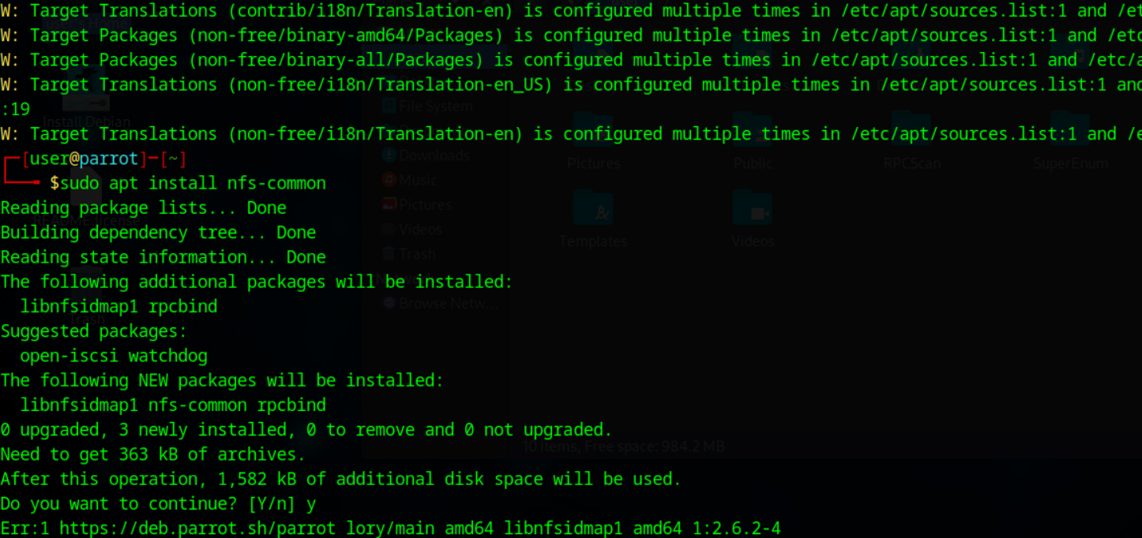

Below the screenshot shows an Nmap scan targeting port 2049 on the IP 192.168.1.131 (server IP) which is running NFS (Network File System).

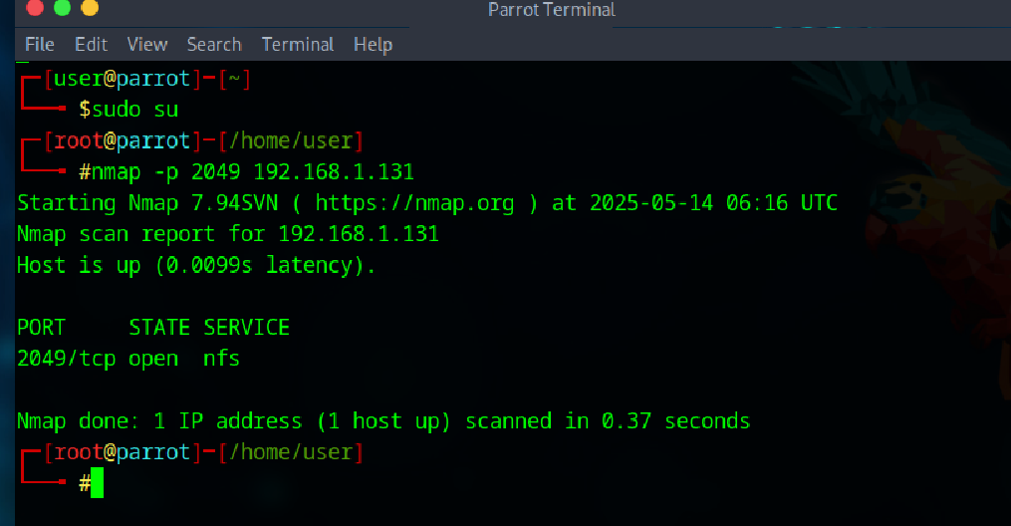

Scanning of an IP of the server using superenum tool

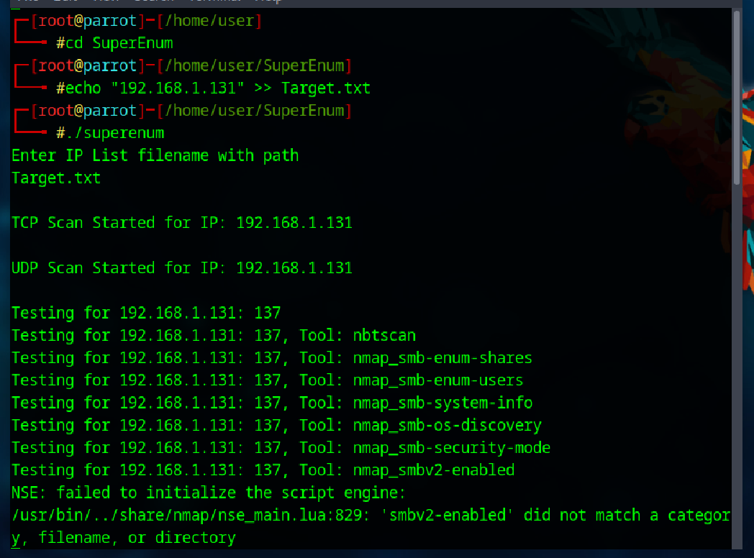

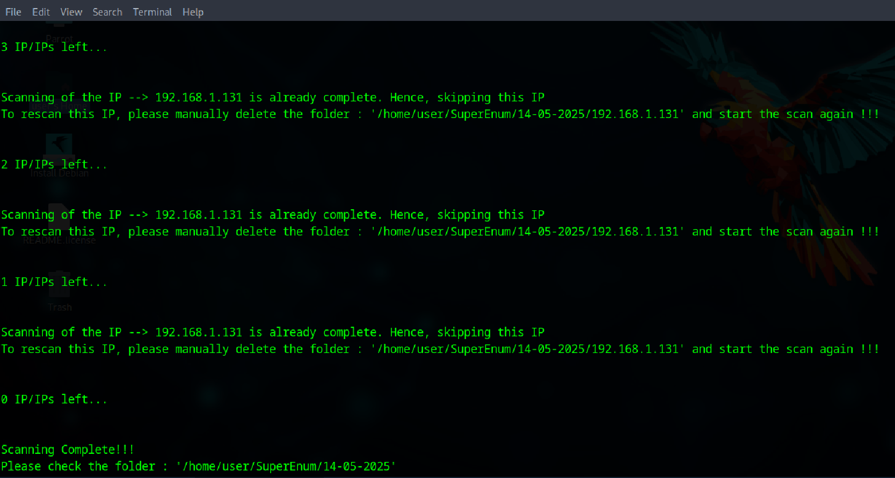

NFS Enumeration using RPC (Portmapper) 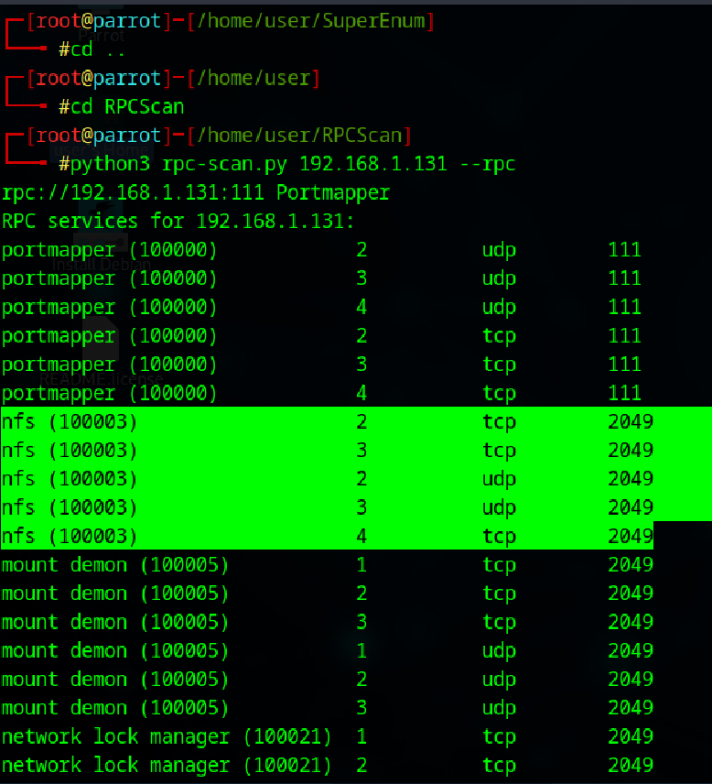

**Lab 5**

**Perform DNS Enumeration**

In this lab you likely perform DNS enumeration using tools like nslookup, dig, dnsenum, or Nmap scripts (dns-brute, dns-recursion). The goal is to identify potential vulnerabilities, misconfigurations (e.g., open DNS resolvers), or hidden subdomains that could be exploited in later attack phases. Techniques may include zone transfers (AXFR queries), brute-forcing subdomains, or analyzing DNS records (A, MX, TXT). Proper DNS enumeration helps ethical hackers map the attack surface and strengthen defenses by uncovering weak points in the target's DNS architecture.

**Task-1: DNS enumeration using zone transfer**

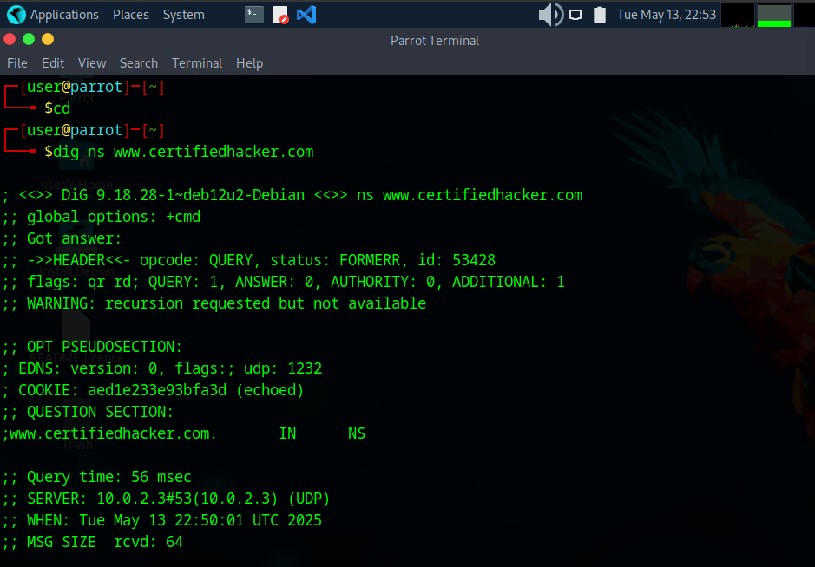

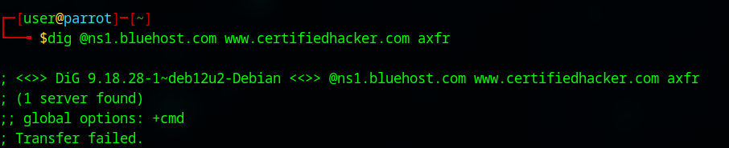

These screenshots show that the server is available but the transfer failed. After retrieving the DNS name server information, the attacker can use one of the servers to test to check if the target DNS allows zone transfer or not. In this case the zone transfers are not allowed.

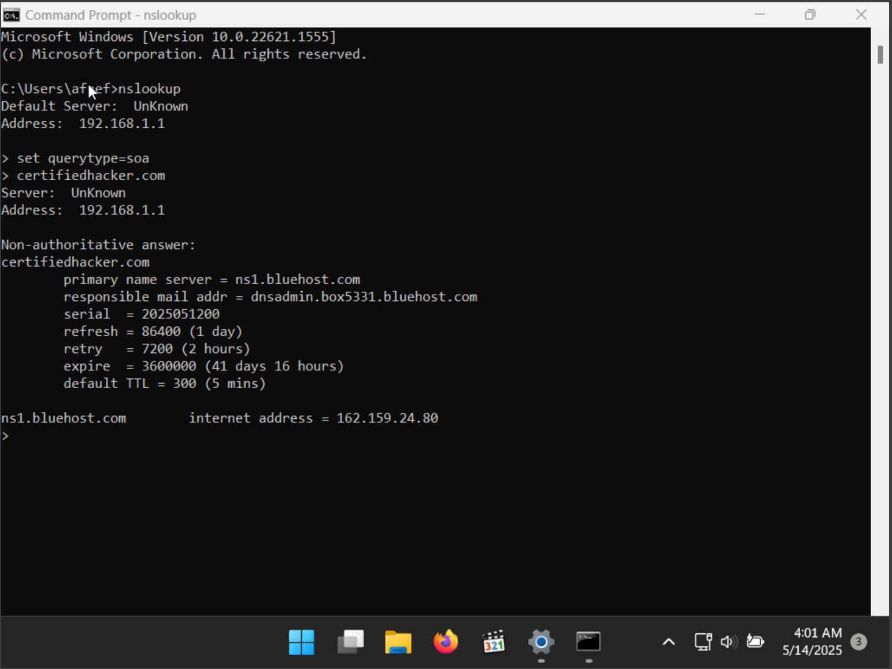

**set querytype=soa** sets the query type to SOA (Start of Authority) record to retrieve administrative information about the DNS zone of the target domain [**certifiedhacker.com**](http://certifiedhacker.com). The result appears, displaying information about the target domain such as the primary name server and responsible mail address, as shown in the screenshot.

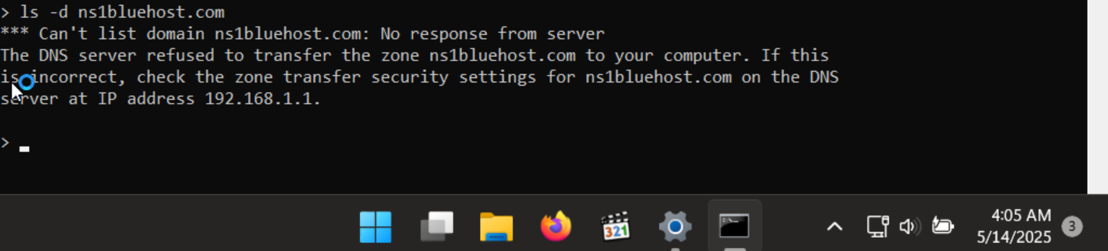

The result appears, displaying that the DNS server refused the zone transfer, as shown in the screenshot. After retrieving DNS name server information, the attacker can use one of the servers to test whether the target DNS allows zone transfers or not. In this case, the zone transfer was refused for the target domain. A penetration tester should attempt DNS zone transfers on different domains of the target organization.

This concludes the demonstration of performing DNS zone transfer using dig and nslookup commands.

**Task-2: DNS enumeration using DNSSEC zone Walking**

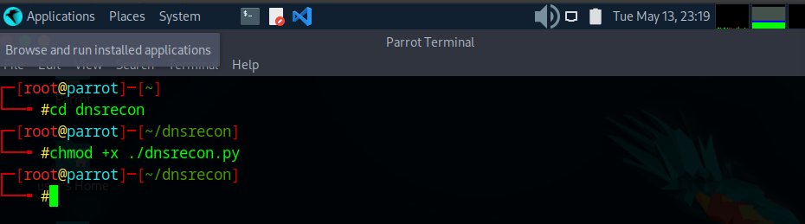

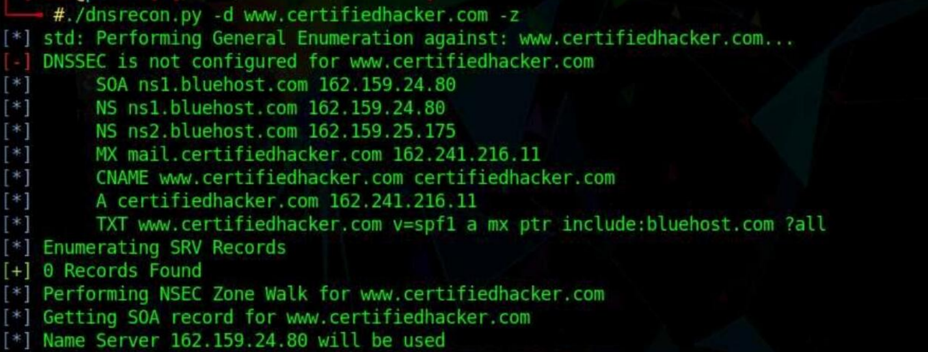

Using the DNSRecon tool, the attacker can enumerate general DNS records for a given domain (MX, SOA, NS, A, AAAA, SPF, and TXT). These DNS records contain digital signatures based on public-key cryptography to strengthen authentication in DNS.

**Task-3: DNS enumeration using Nmap**

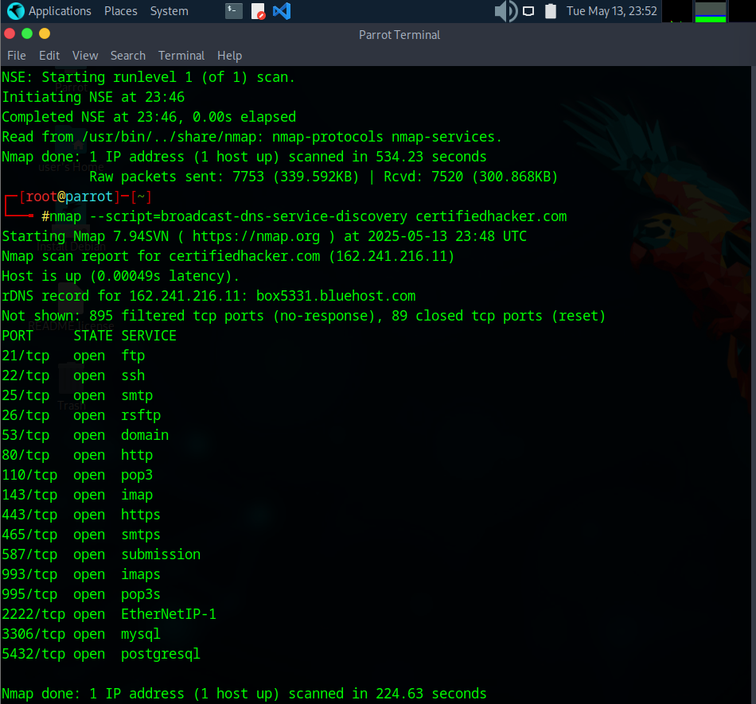

The result appears displaying a list of all the available DNS services on the target host along with their associated ports, as shown in the screenshot.

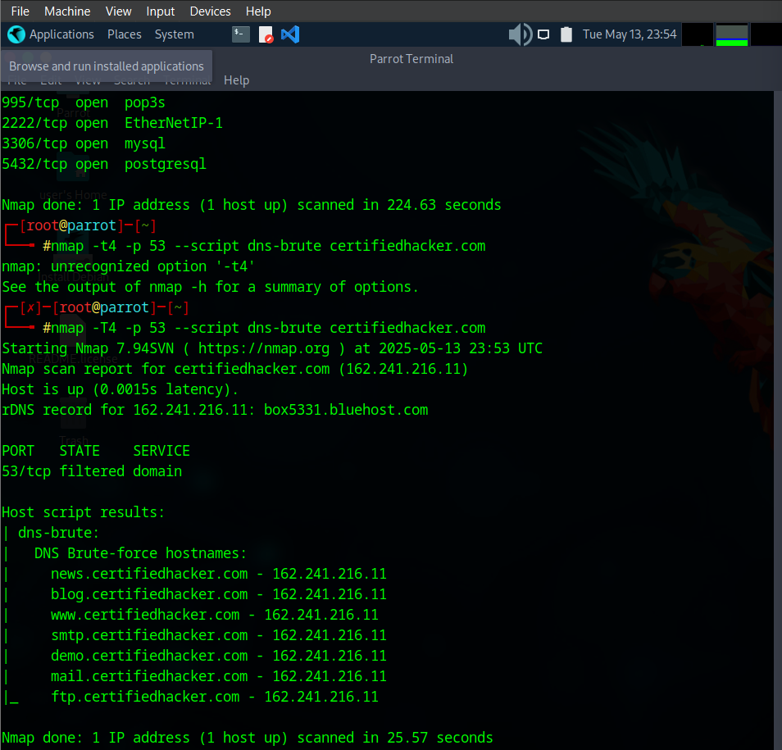

The result appears displaying a list of all the subdomains associated with the target host along with their IP addresses, as shown in the screenshot.

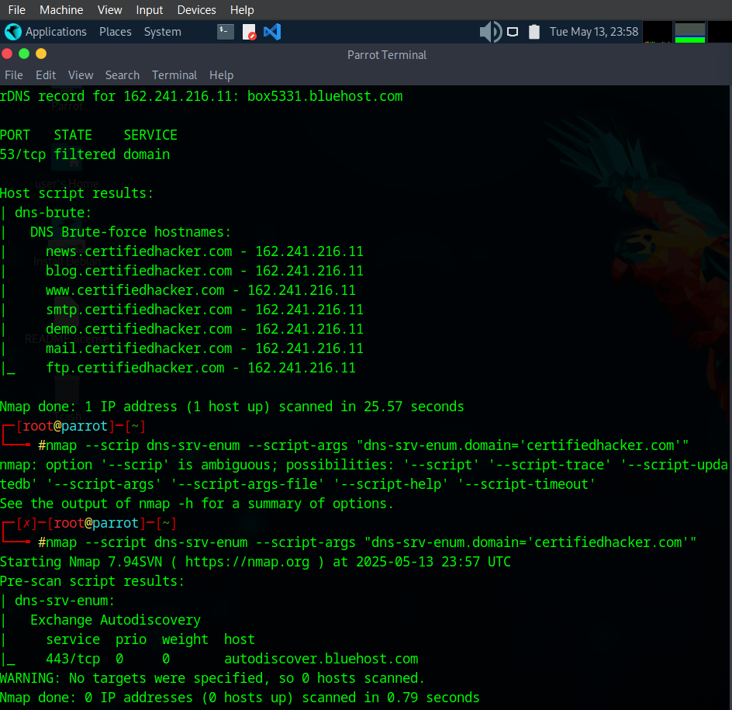

The result appears displaying various common service (SRV) records for a given domain name, as shown in the screenshot. Using this information, attackers can launch web application attacks such as injection attacks, brute-force attacks and DoS attacks on the target domain.

**Lab 6**

**Perform SMTP Enumeration**

The SMTP enumeration lab provides important insights into how attackers and penetration testers gather information about mail servers and their user accounts. Through this lab, we understand how the Simple Mail Transfer Protocol (SMTP), commonly used for sending emails, can be probed to identify valid user accounts, available services, and potential vulnerabilities. SMTP typically operates on TCP port 25, and by leveraging tools like Nmap, we can automate the discovery of critical information.

By using specific Nmap scripts such as smtp-enum-users, we successfully obtained a list of valid users on the target SMTP server. These usernames—including "root", "admin", "webadmin", and "guest"—can be exploited further for password guessing or brute-force attacks. This reinforces the need for organizations to avoid using default or predictable usernames and to implement rate-limiting and monitoring on their SMTP servers.

Moreover, the lab utilized the smtp-commands script to list all the supported SMTP commands on the server. This provided deeper visibility into the mail server's capabilities and configurations, revealing that it supports commands such as VRFY, ETRN, AUTH, and STARTTLS. These commands, if not properly secured, can be leveraged by attackers to further probe the system or attempt credential-based attacks. The exposure of such detailed information through automated scanning emphasizes the need for secure configuration and regular audits of mail servers.

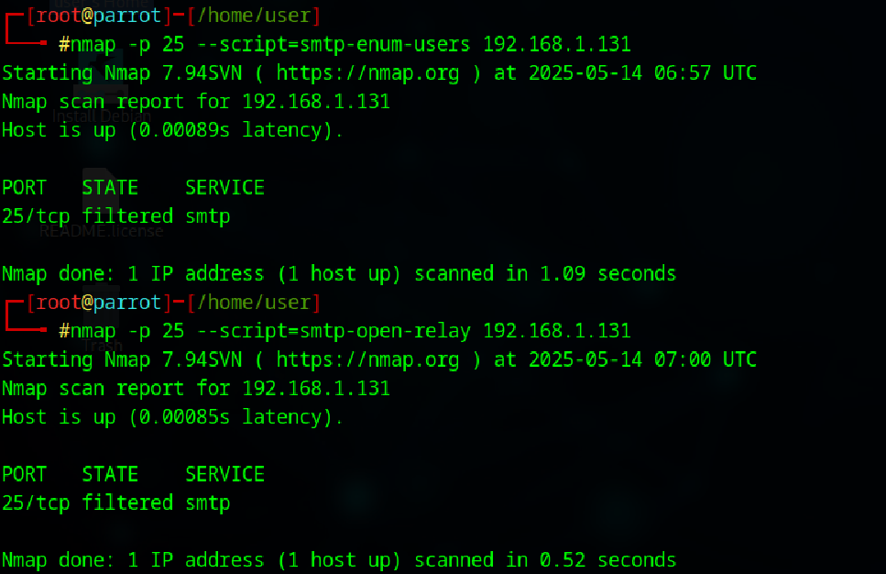

**Lab 7**

**Task-1: Perform SMB and RPC Enumeration using NetScanTools Pro**

In this task we are using SMB scanner to get information such as the NetBIOS Name, DNS Name, SMB versions, and Shares for each target IP address like in the screenshot below.

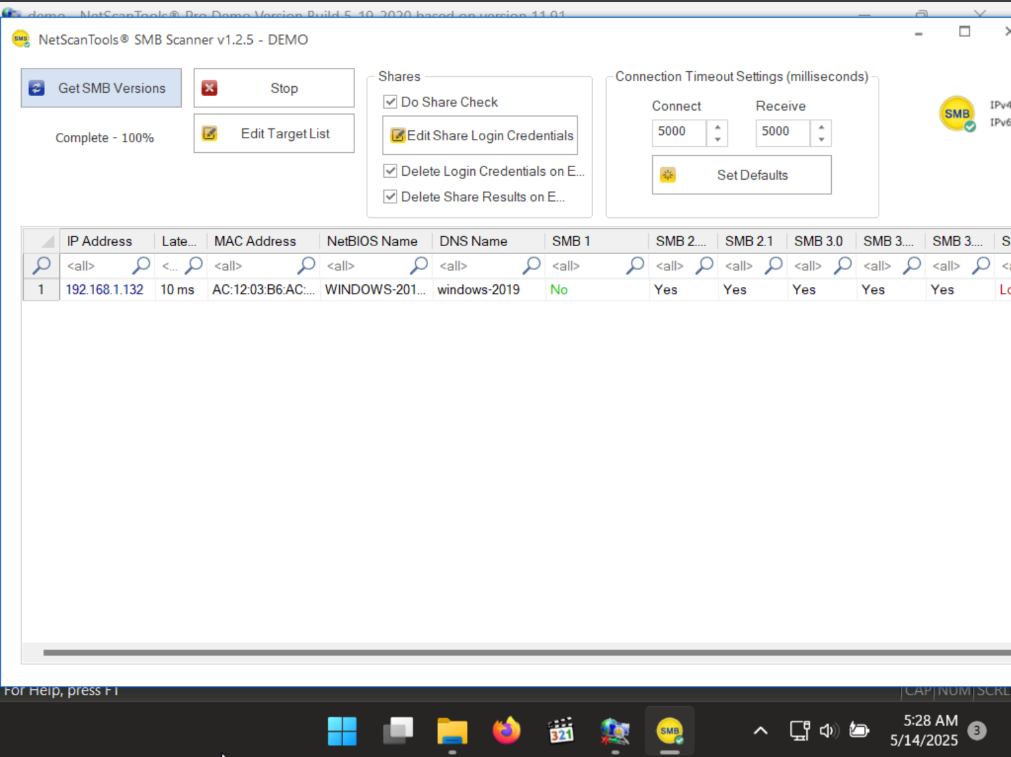

**nix RPC** Info option, is used to get the RPC information of server as in the screenshot below

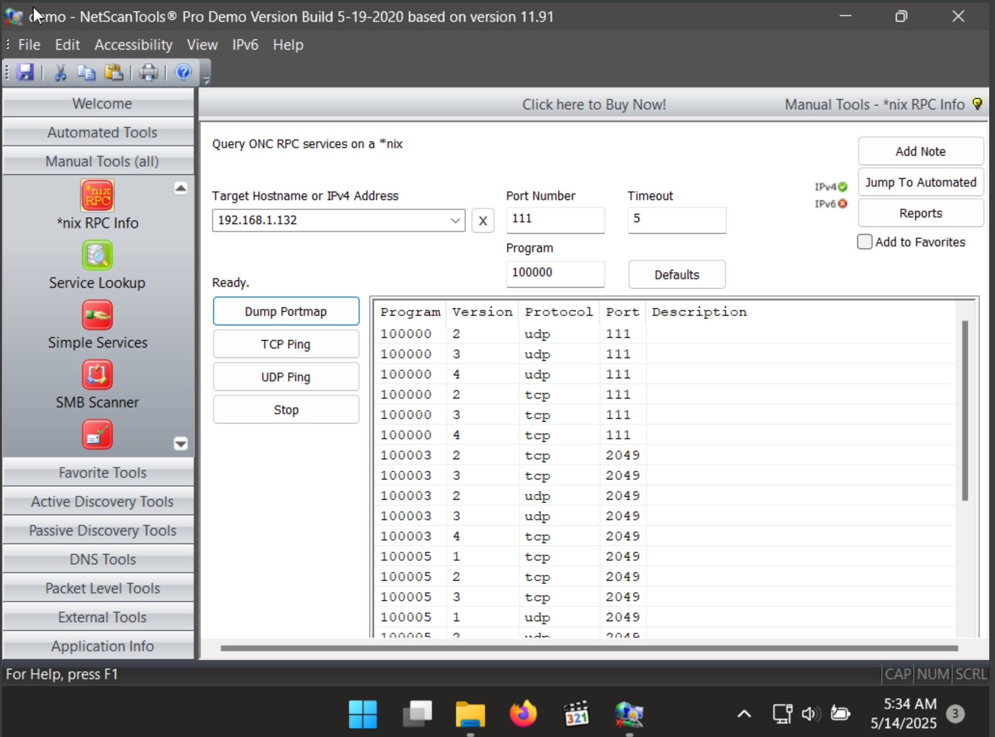

Enumerating RPC endpoints enables attackers to identify any vulnerable services on these service ports. In networks protected by firewalls and other security establishments, this portmapper is often filtered. Therefore, attackers scan wide port ranges to identify RPC services that are open to direct attack.

**Task-2: Perform RPC, SMB, and FTP Enumeration using Nmap**

Initially we are going to configure the FTP service in the target machine which in this case is Window server 2019. After that we are going to check if port 21 is open which is shown in the screenshot below.

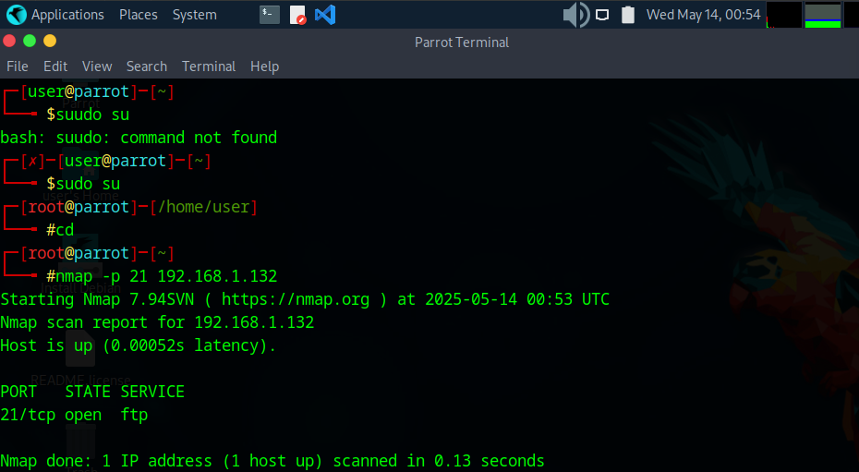

Now we are going to perform a complete aggressive scan of the target server 2019 machine as in the below screenshot.

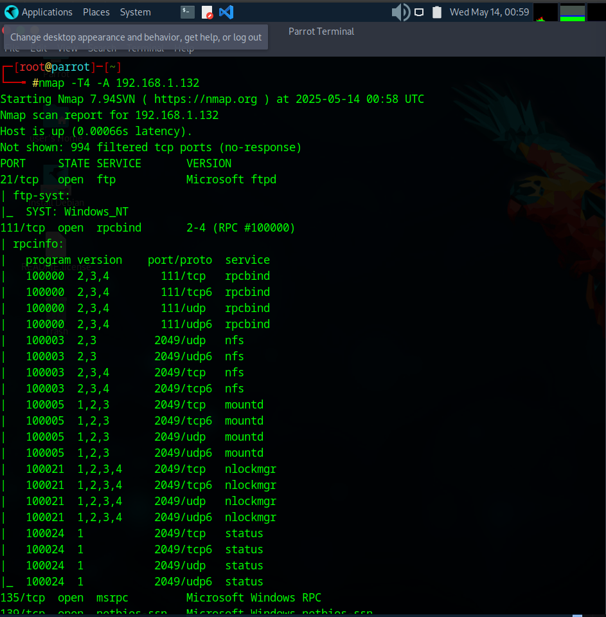

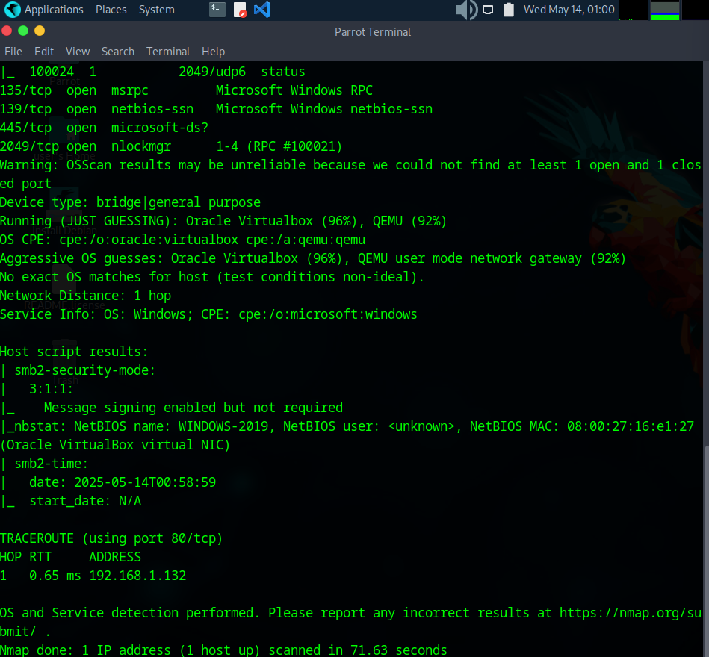

The scan result appears, displaying information regarding open ports, services along with their versions. You can observe the RPC service and NFS service running on the ports 111 and 2049, respectively, as shown in the screenshot.

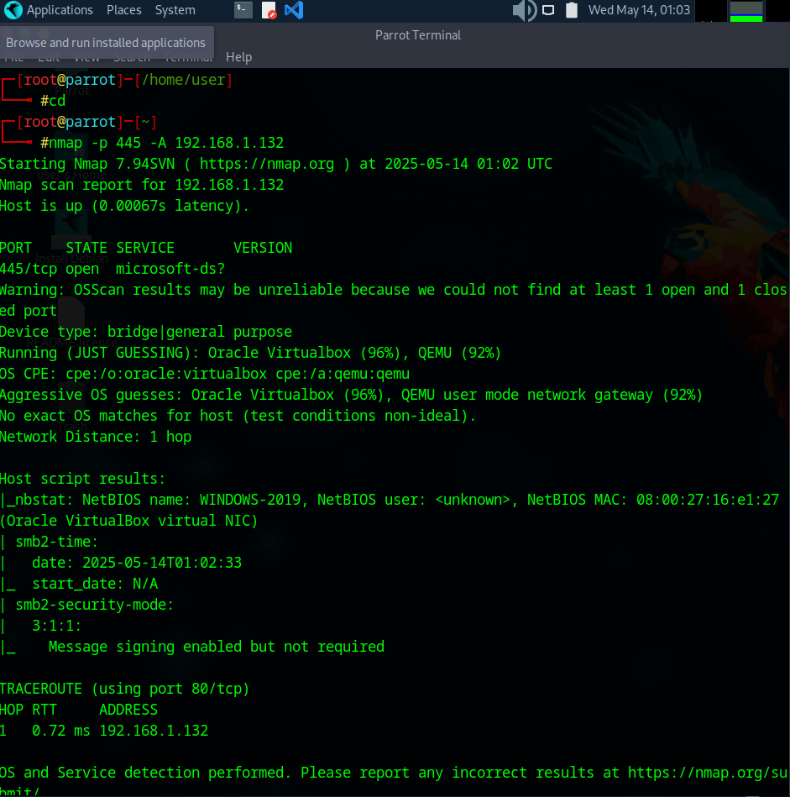

The scan result appears, displaying that port 445 is open, and giving detailed information under the Host script results section about the running SMB, as shown in the screenshot.

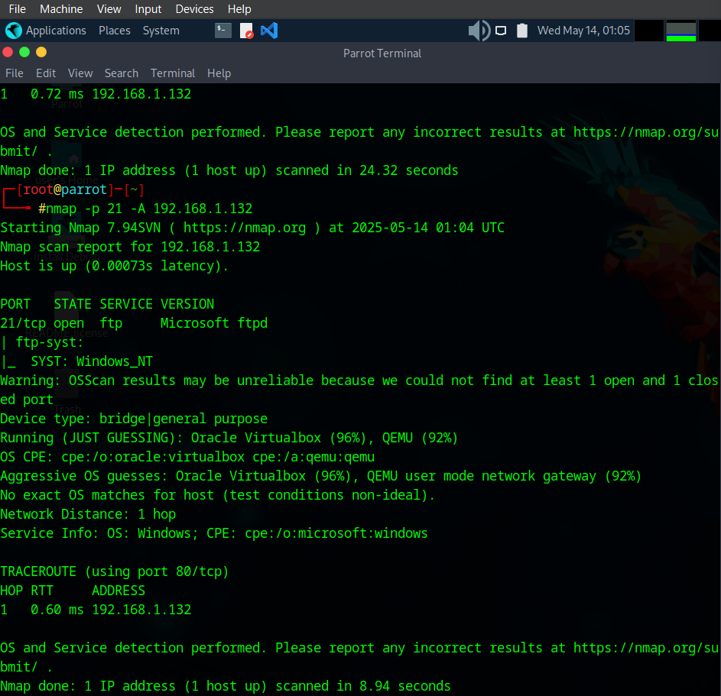

The scan result appears, displaying that port 21 is open, and giving traceroute information, as shown in the screenshot.

Using this information, attackers can further identify any vulnerable service running on the open service ports and exploit them to launch attacks. This concludes the demonstration of performing RPC, SMB, and FTP enumeration using Nmap.

**Module 5 : Vulnerability Analysis**

**Lab 1**

**Task 1: Perform vulnerability research in Common Weakness Enumeration (CWE)**

This lab focuses on vulnerability research using standardized scoring systems and databases to identify and assess security weaknesses in target systems. As an ethical hacker or penetration tester, the first step involves leveraging resources like Common Weakness Enumeration (CWE), Common Vulnerabilities and Exposures (CVE), and the National Vulnerability Database (NVD) to analyze vulnerabilities systematically. These tools provide structured frameworks for ranking vulnerabilities based on severity, risk, and potential impact, enabling security professionals to prioritize threats and devise mitigation strategies.

The lab environment requires a Windows 11 virtual machine with internet access and administrator privileges to explore these databases effectively. By understanding how vulnerabilities are cataloged and scored, learners gain critical insights into identifying software flaws, assessing exploit potential, and hardening systems against attacks—key skills for cybersecurity professionals.

The lab underscores the ethical responsibility of using such tools to improve security rather than exploit weaknesses, reinforcing principles of ethical hacking and countermeasures.

Accessing <https://cwe.mitre.orrg> using mozilla firefox on Windows 11

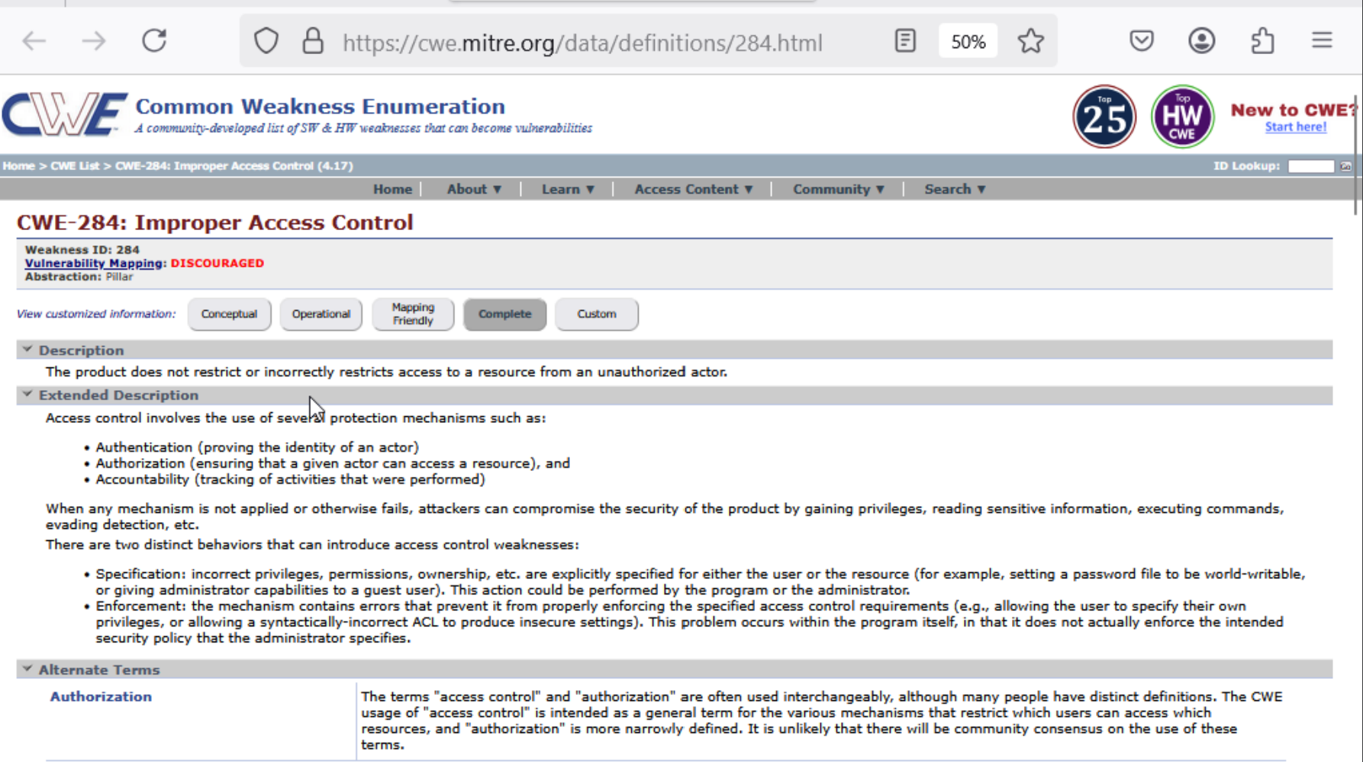

Top 25 most dangerous software weaknesses

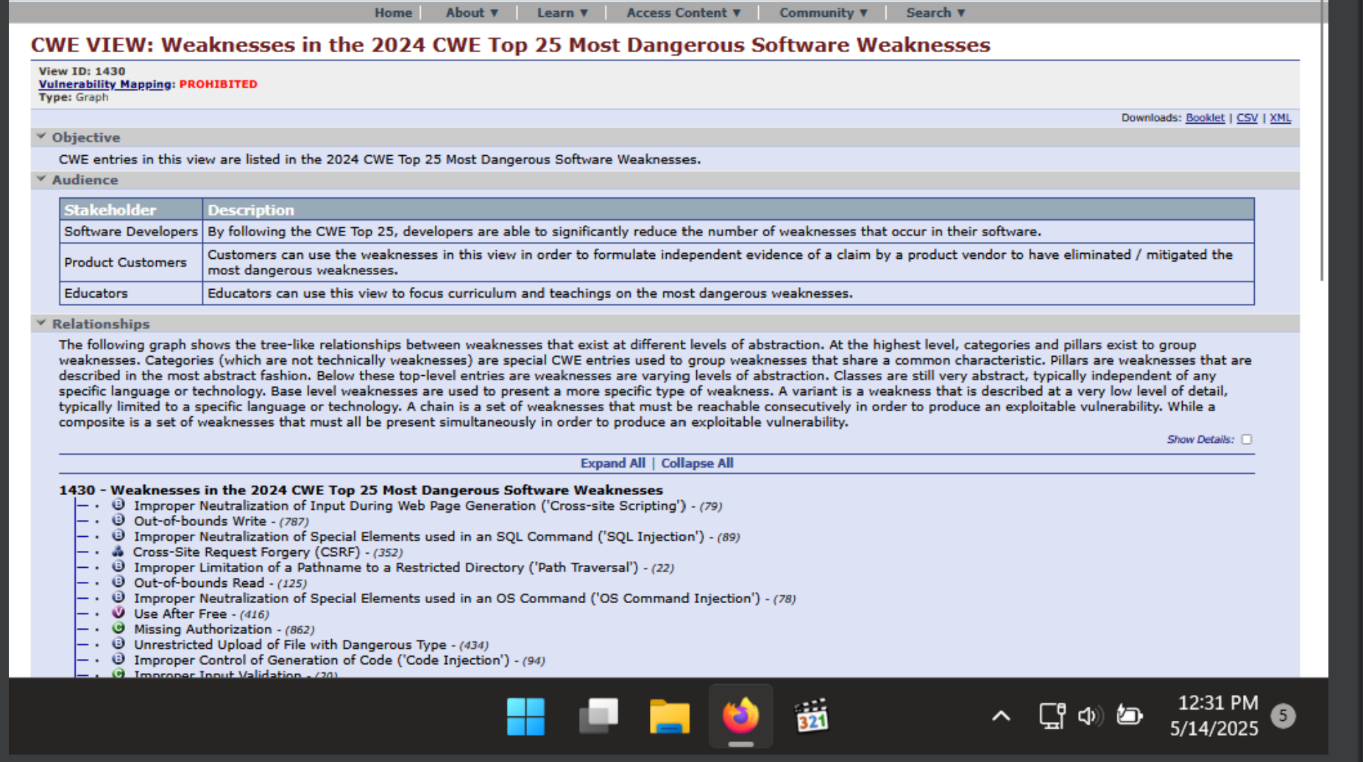

**Task 2:** **Perform vulnerability research in Common Vulnerability and Exposure (CVE)**

Used [www.cve.org](http://www.cve.org) to search a vulnerability (CVE-2021-4034)

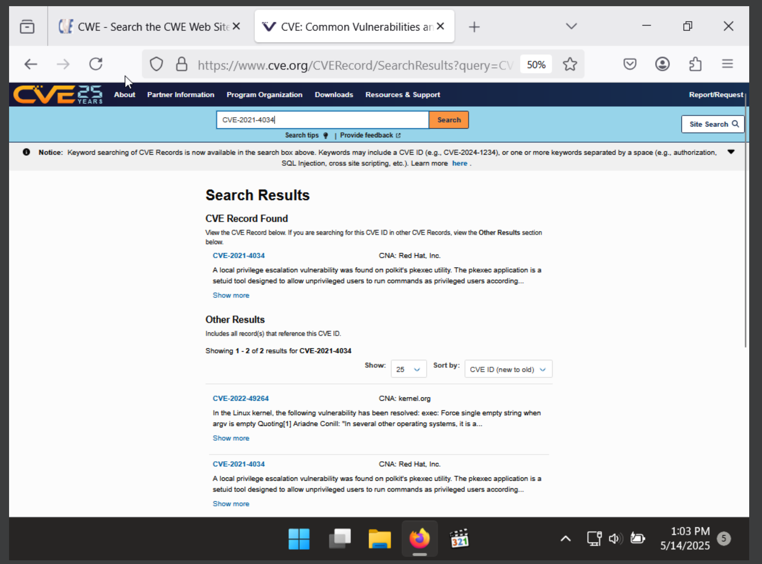

Searching for CVE-2021-44228

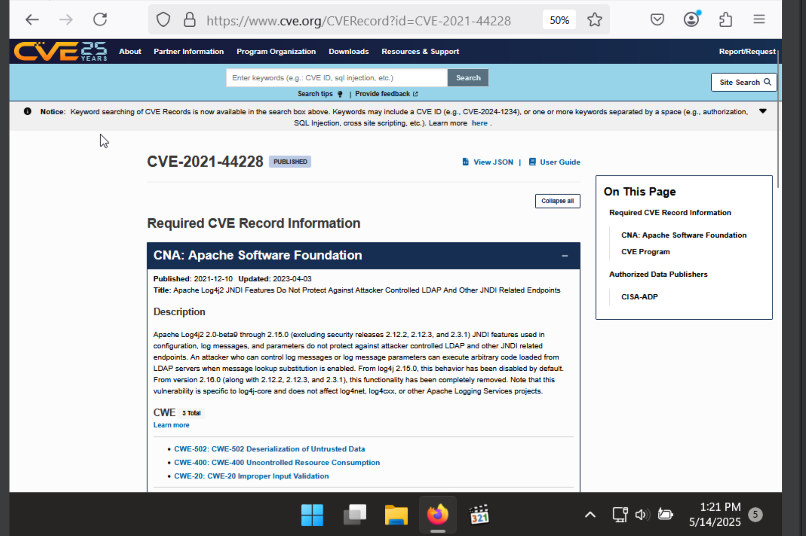

**Task 3:** **Perform vulnerability research in National Vulnerability Database (NVD)**

In the National Vulnerability Database (NVD), the Base Score is a numerical value ranging from 0.0 to 10.0 that represents the severity of a security vulnerability. It is derived using the Common Vulnerability Scoring System (CVSS) and helps organizations prioritize which vulnerabilities need urgent attention. The base score considers factors such as how easily the vulnerability can be exploited (e.g., whether it requires user interaction or special privileges) and the potential impact on system confidentiality, integrity, and availability. Based on the score, vulnerabilities are categorized as None (0.0), Low (0.1–3.9), Medium (4.0–6.9), High (7.0–8.9), or Critical (9.0–10.0).

Below is a base score metric for CVE 2025-0793

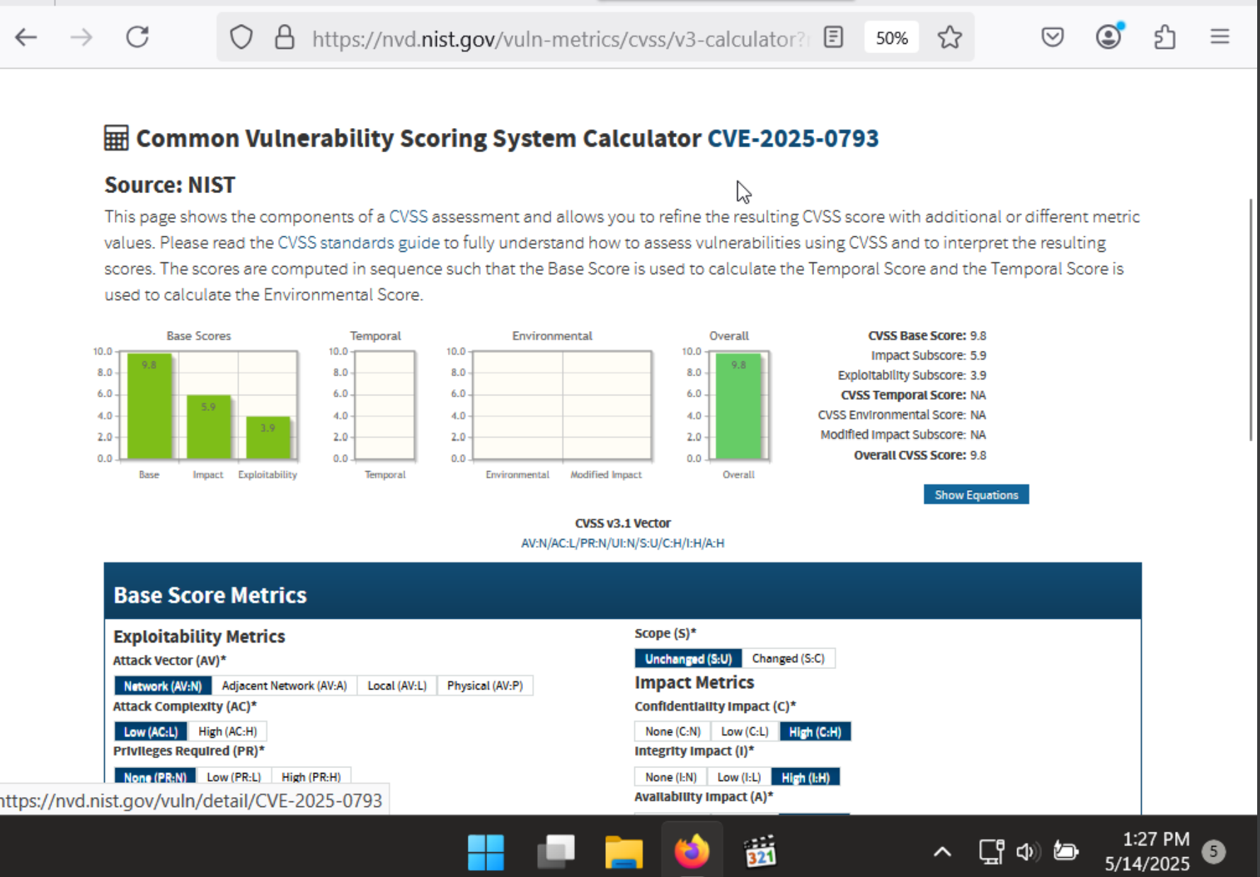

The Temporal Score in the National Vulnerability Database (NVD) is a component of the CVSS (Common Vulnerability Scoring System) that adjusts the Base Score to reflect factors that may change over time. While the Base Score represents the inherent severity of a vulnerability, the Temporal Score considers the current state of exploitability, remediation, and confidence in the vulnerability report

The Environmental Score in the National Vulnerability Database (NVD) is the final component of the CVSS (Common Vulnerability Scoring System) that allows organizations to customize the severity of a vulnerability based on their specific environment. While the Base Score reflects the general severity, and the Temporal Score adjusts it based on current exploit conditions, the Environmental Score further refines the rating by considering how the vulnerability impacts a particular organization’s systems, data, and security requirements.

Below is a screenshot attached to show both the temporal score and environmental score for CVE 2025-0793

